**Step-1**

Create 2 ubuntu instances

1. Server
2. Controller

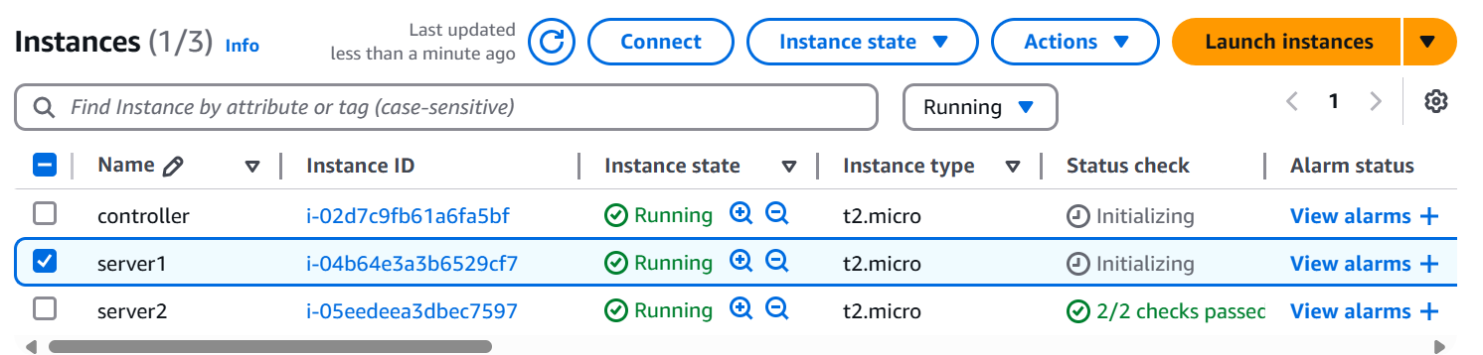

**Step-2**

Connect to server1

Ubuntu machine default comes with python 3

But we need pytho 2

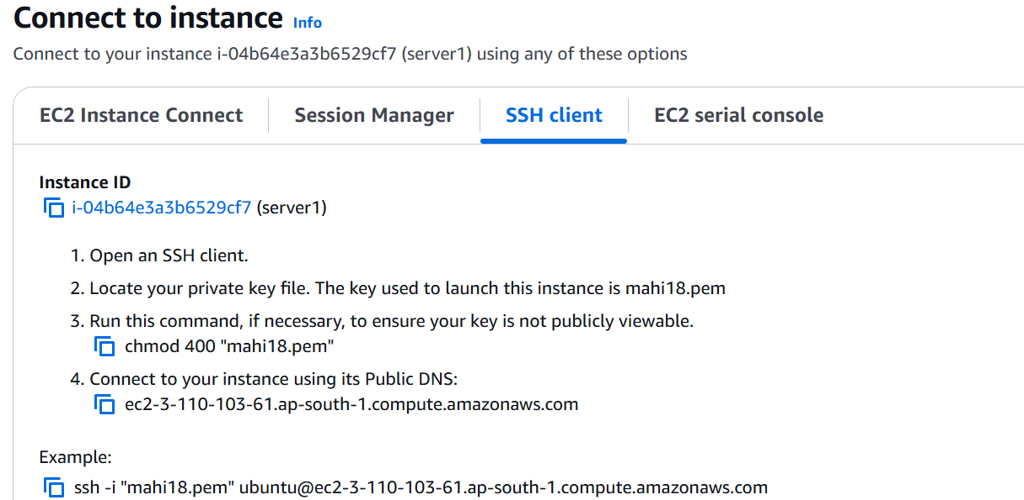

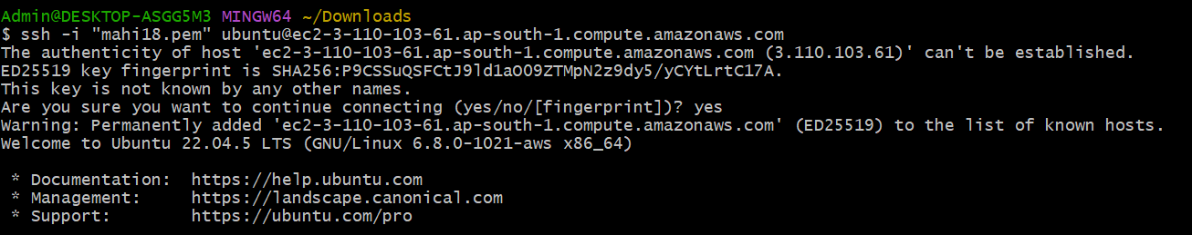

**Step-3**

Update apt repository

sudo apt-get update

Install python2

sudo apt-get install -y python2.7 python-pip

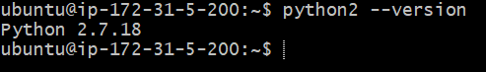

**Step-4**

Establish password less connection between controller and managing nodes(server1 and server2)

sudo passwd ubuntu (give password as ubuntu)

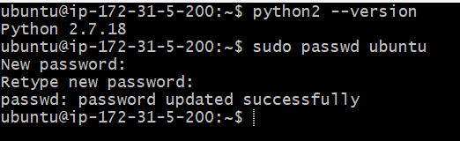

**Step-5**

sudo vim /etc/ssh/sshd_config





Change password authentication to yes

Save and quit

Restart the service

sudo service ssh restart

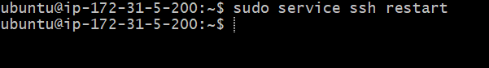

exit

**Step-6**

Same procedure For Controller

Now connected to controller Update the repository

sudo apt-get update

Install python 2

sudo apt-get install -y python2.7 python-pip

Generate the keys

ssh-keygen

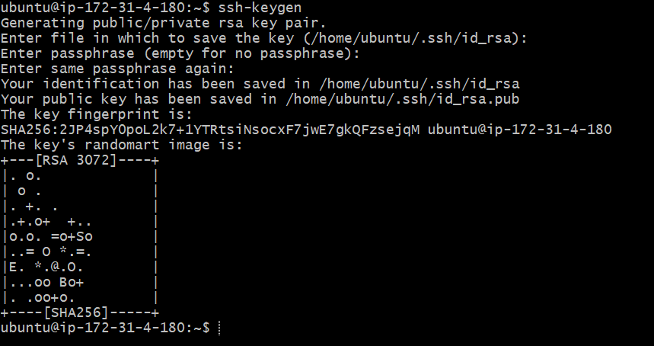

**Step-7**

vim .ssh/id_rsa.pub

ssh-rsa  ubuntu@ip-172-31-4-180

Exit

**Step-8**

Connect to server

vim .ssh/authorized_keys --> paste the above key

Exit

**Step-9**

Connect to controller machine

ssh -v ubuntu@ server ip address

Same procedure for server 2 (copy paste the keys)

exit

**Step-10**

Connect to controller

Install the ansible

Sudo apt-get install software-properties-common



Sudo apt-add-repository ppa:ansible/ansible



sudo apt-get update

sudo apt-get install -y ansible

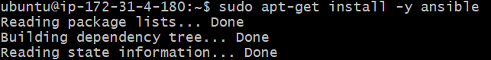

Write the ip adresses of managing nodes in the inventory file

Cd /etc/ansible (server ip address)

$ls

Sudo vim hosts (copy paste server1 and 2 ip addresses)

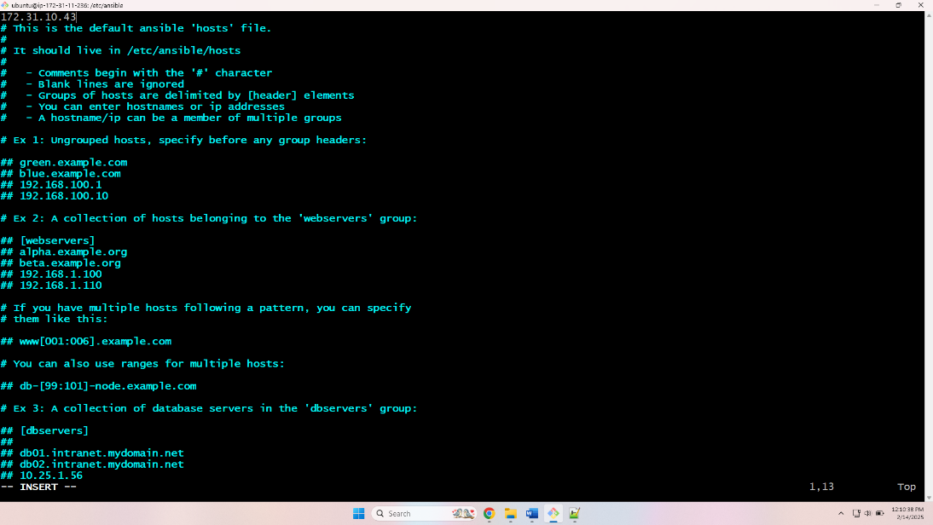

**Step-11**

Create files in server1 and 2 from controller

ansible all -i/etc/ansible/hosts -m command -a 'touch f1 f2 f3'

To check files are created or not

Ssh 172.31.5.200

$ls

